**Information System Department**

**Faculty of Computers and Information**

**Cairo, Egypt**

**Data Warehousing**

**Academic Year 2014/2015**

**Phase #2**

**DB source name: Credit DB**

***Done By: Islam Ibrahim***

MemberDim Query:-

select member.member_no,

member.lastname as member_name, member.phone_no as member_phone

from member

MemberDim details:-

1- Dimension: MemberDim.

2- Dimension level: No levels.

3- Dimension Attributes: member_no, member_name, member_Phone.

4- Dimension Measures: No measures.

5- Dimension Sources : all attributes are extracted from the member table from CreditDB.

6- Equation of Transformation: No equations.

ProviderDim Query:-

select provider.provider_no,

provider.provider_name, provider.country as provider_country

from provider

ProviderDim details:-

1- Dimension: ProviderDim.

2- Dimension level: No levels.

3- Dimension Attributes: provider_no, provider_name, provider.country.

4- Dimension Measures: No measures.

5- Dimension Sources : all attributes are extracted from the provider table from CreditDB.

6- Equation of Transformation: No equations.

CorporationDim Query:-

select corporation.corp_no, corporation.city,

corporation.corp_name, corporation.phone_no,

corporation.country

from corporation

CorporationDim details:-

1- Dimensions: CorporationDim.

2- Dimension level: two levels ( city, country ).

3- Dimension Attributes: corp_no, corp_name, phone_no, country.

4- Dimension Measures: No measures.

5- Dimension Sources : all attributes are extracted from the corporation table from CreditDB.

6- Equation of Transformation: No equations.

DateDim Query:-

select charge.charge_dt, DAY(charge.charge_dt) as charge_day,

MONTH(charge.charge_dt) as charge_month,

YEAR(charge.charge_dt) as charge_year

from charge

DateDim details:-

1- Dimensions: DateDim.

2- Dimension level: three levels ( day, month, year ).

3- Dimension Attributes: charge_day, charge_month, charge_year.

4- Dimension Measures: No measures.

5- Dimension Sources : all attributes are extracted from the charge table from CreditDB.

6- Equation of Transformation: No equations.

ChargeFact Query:-

select SUM(charge.charge_amt) as total_charges,

SUM(payment.payment_amt) as total_payments,

member.member_no, provider.provider_no,

corporation.corp_no,charge.charge_dt

from charge,payment,member,provider,corporation

where member.corp_no=corporation.corp_no

and payment.member_no=member.member_no

and charge.member_no=member.member_no

and charge.provider_no=provider.provider_no

group by member.member_no, provider.provider_no,

corporation.corp_no,charge.charge_dt

ChargeFact details:-

2- Fact level: No levels.

3- Fact Attributes: total_charges, total_payments, member_no, provider_no, corp_no, charge_dt.

4- Fact Measures: total_charges, total_payments.

5- Fact Sources : total_charges, charge_dt are extracted form charge table from CreditDB, total_payments is extracted from payment table from CreditDB, member_no is extracted from member table from CreditDB, provider_no is extracted from provider table from CreditDB, corp_no is extracted from corporation table from CreditDB.

6- Equation of Transformation:

1- total_charges = SUM(charge.charge_amt)

2- total_payments = SUM(payment.payment_amt)

**The Data Warehouse Schema Filled with Data:**

In the cube

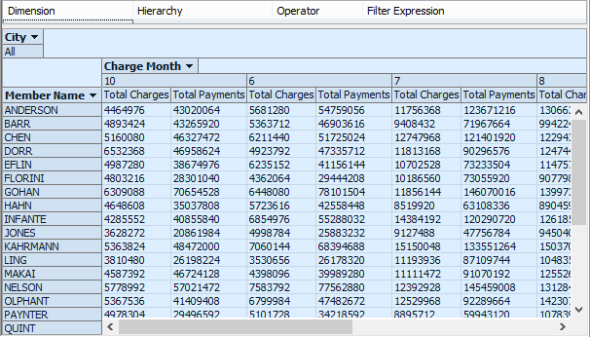

Charge Fact table in SQL server

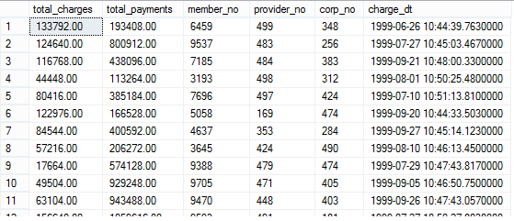

DateTime dimension in SQL server

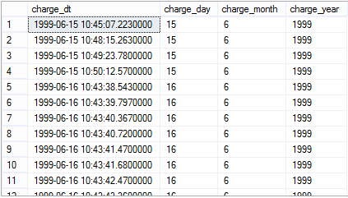

**Our Cube for analysis in Visual studio:**

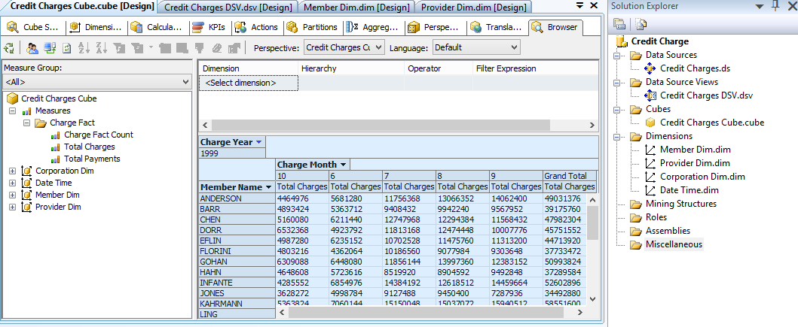

**Excel report:**

The report shows the member and total charges for the data hierarchy filtered by the Corporation "Apex key StonesAg."

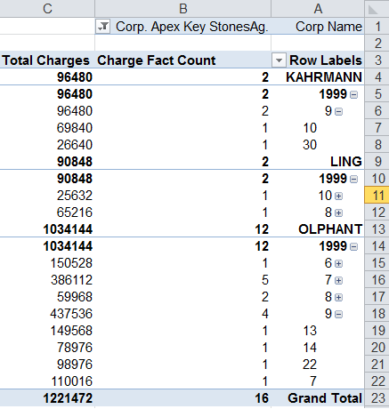

**Extra report (bonus part):**

The report generated by Visual studio and shows the member and corporation names and the total charge for several months

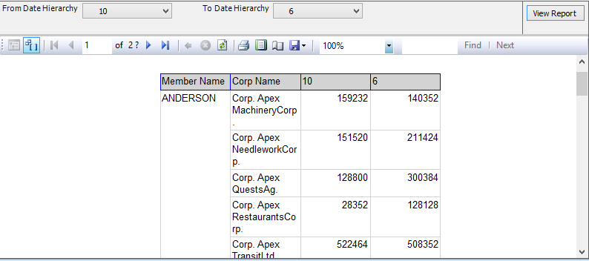

**Excel graph:**

The graph shows the member names versus the total payments.

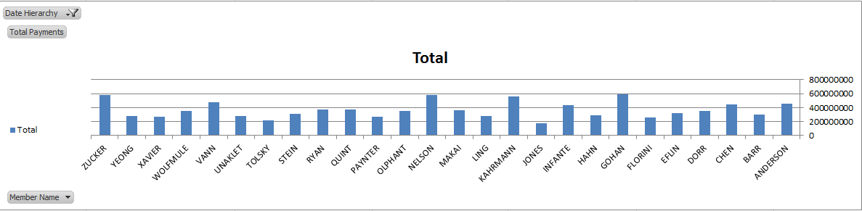

**MDX Query (Two children function):**

SELECT [Member Dim].[Member Name].children on rows,

[Date Time].[Charge Month].children on columns

FROM [Credit Charges Cube]

WHERE [Measures].[Total Payments]